

# Pre-board Examination - 2024

**Subject: IT 241: Operating System FM: 60**

**Semester: BIM 4th Semester Time:3 hrs**

**Very Short Answer Question(10*1=10)**

1. What do you mean by a process?

### What is Real Time Operating system?

### Define binary Semaphore?

1. What is starvation?
2. what is paging and segmentation?
3. Define the term indefinite postponement.
4. What is ostrich algorithm?
5. Define Remote procedure call?
6. Differentiate between sequential and direct file access method.
7. What is antivirus and antispyware?

**Short Answer Question (5*3=15)**

1. Differentiate between monolithic and microkernel?
2. Differentiate between preemptive and non-preemptive scheduling algorithm
3. Describe various method for deadlock prevention.
4. What is Race condition? Explain with print spooler example.
5. What is distributed operating system? List its advantages.
6. What are file operations? Explain about hierarchical directory system with diagrammatic examples.

**Answer Questions (3*5=15)**

1. What is Counting semaphore? Discuss the producer-consumer problem using semaphores.
2. **Considering a system with five processes P0 through P4 and three resources of type A, B, C. Resource type A has 10 instances, B has 5 instances and type C has 7 instances. Suppose at time t0 following snapshot of the system has been taken:** 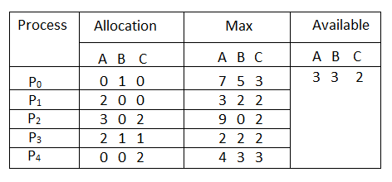
3. **Find total resource vector TRV and Need Matrix.**
4. **Is the system in safe state?**
5. **If the request from process p1 arrives for (0,4,2) can the request be granted immediately?**
6. Define the term page fault and thrashing. Consider the following page reference string :1,3,5,1,7,1,5,5,1,4,3,7,6,3,4,1. How many page fault will occur for each of the following page replacement algorithm assuming 3-page frame.
7. **FIFO Page Replacement algorithm**
8. **LRU Page Replacement algorithm**
9. **Optimal Page Replacement algorithm**
10. Differentiate between programmed I/O and Interrupt driven I/O

**Long Answer Questions(2*10= 20)**

1.Write the CPU scheduling criteria. For process listed in the following table, draw gantt chart illustrating their execution and calculate average waiting time and turnaround time using

1. **First come first served**
2. **Shortest Job First**
3. **Priority**
4. **Round Robin (quantum= 2ms)**

|  |  |  |  |
| --- | --- | --- | --- |
| **Process** | **Arrival time** | **Burst time** | **Priority** |
| P0 | 0 | 7 | 3 |
| P1 | 1 | 8 | 1 |
| P2 | 2 | 2 | 4 |
| P3 | 3 | 2 | 2 |

1. Consider a disk drive has 500 cylinders, numbered 0 to 4999.The drive is currently serving request at cylinder 143,and the previous request was at cylinder 125. The queue of pending request in FIFO order is 86,1470,913,1774,948,1509,1022,1750,130.

Starting from the current head position ,what is the total distance that the disk arm moves to satisfy all pending request for each of the following disk scheduling algorithm?

1. **FCFS b. SSTF c. SCAN d. Look**